CS 457 Database Management Systems

Programming Assignment 1

Amir Behmaram and Tanner Jones

2/22/2018

We structured our project as follows. We have a directory in the root directory of our project folder named “Databases” which contains all of the databases and tables. The databases in our project are folders which hold their tables. This allows the existence of multiple databases that can be managed easily since we are using python which has tools to handle directory creation, modification, and deletion easily. Each database folder has a JSON file named (database name).json which contains information about the tables in the database, this may prove useful in later iterations of the project The tables within a databases are represented as separate JSON files. This way, a database with multiple tables will just be a folder with multiple JSON files within the folder. We decided to store the table information in JSON format because python manages JSON files easily. For a diagram of the layout reference Figure 1 below.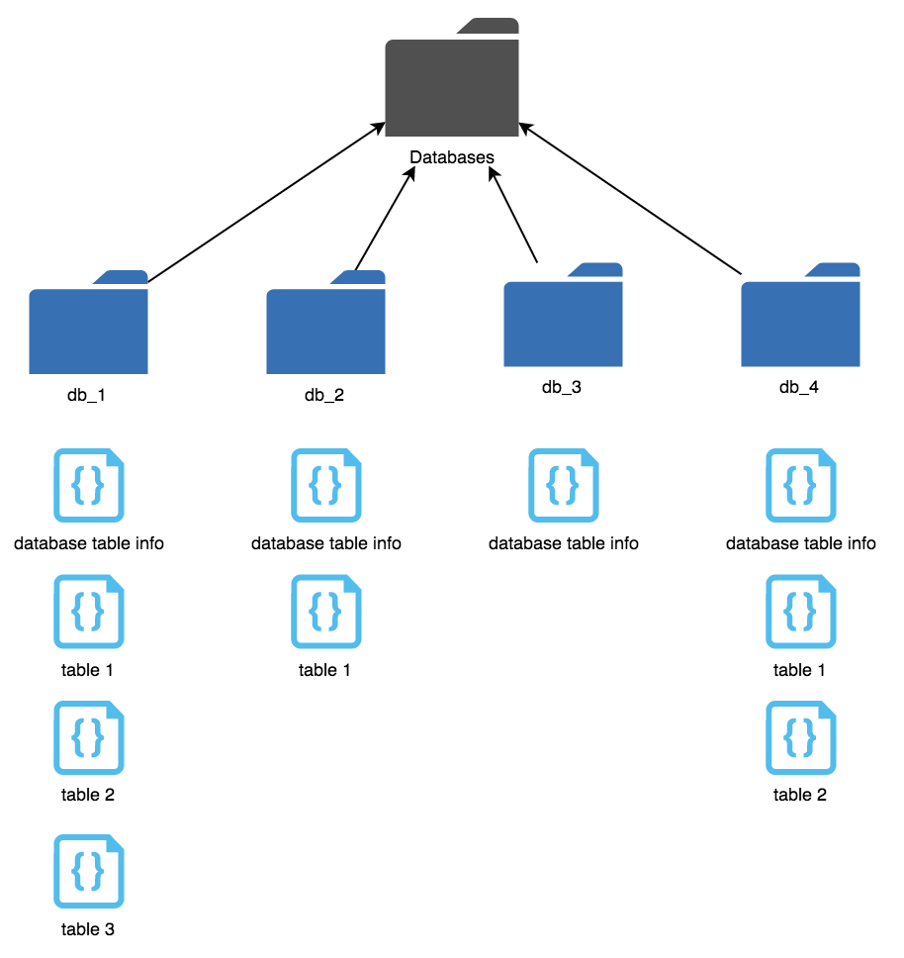

Figure 1: Figure 1 represents a high level diagram of how the project organizes databases and tables.